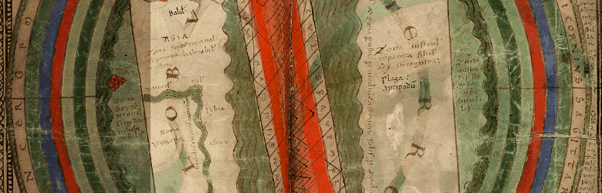

**Henri Pirenne Institute for Medieval Studies**

**2nd semester 2016**

**Other activities**

12 Feb 2nd Symposium on the History and the Philosophy of Science: The Arab-Islamic sciences (9th-14th centuries) in the *longue durée*: The “Scientific Revolution” in question

18-20 Feb Holy Hero(in)es: Literary Constructions of Heroism

in Late Antique and Early Medieval Hagiography

24-25 March Compilations and Excerpt Collections of Historiographical Texts

Date tba Study day on Iran and literature Classical heritage, literary modernity and beyond

15 April The medieval hospital, an epistemological workshop for historians (North-Western Europe, 13th-16th centuries)

19-21 May Finding the Present in the Distant Past: The Cultural Meaning of Antiquarianism in Late Antiquity

16-17 June VWM & RMBLF Study Day & Workshop with Barbara Newman: Dominance & Resistance

**Medieval Seminar Series**

Friday 22 Jan Lunch Meeting **Presentations FWO applications**

Wednesday 17 Feb Lunch Meeting **Stephanos Efthymiadis: The Disabled in the Byzantine Empire**  Blandijn Lokaal 100.024, 1-2 pm

Friday 1 April Bronnenseminar 1: **Oorkonden Vroegste Communale Instellingen in Vlaamse steden** (Jan Dumolyn & Ewoud Waerniers)

UFO, Vergaderzaal Archeologie, 2-5 pm, followed by drinks reception

Friday 15 April Lunch Meeting **Anne Breitbarth & Melissa Farasyn: A parsed Corpus of Historical Low German (CHLG)** Blandijn lokaal 120.043, 1-2 pm

Friday 29 April Lunch Meeting **Suraiya Faroqhi: The emergence of guilds in an Ottoman setting** UFO, Vergaderzaal Archeologie, 1-2 pm

Friday 20 May Lunch Meeting **Emilia Jamroziak: Late Medieval Cistercian Communities and the Cult of Saints as a Trans-European and Regional Phenomenon**. UFO, Vergaderzaal Archeologie, 1-2 pm

Friday 10 June Bronnenseminar 2 **Lekendevotie in de 15de- en 16de-eeuwse Nederlanden: Kerkrekeningen, testamenten, visuele en materiële bronnen** (Ruben Suykerbuyk & Miyako Sugiyama) UFO, Vergaderzaal Archeologie., 1-2 pm, followed by drinks reception

June MSS Lunch Meeting, 1-2 pm. TBA

